Science Department Policy Document: Literacy and Numeracy

The following is a work-in-progress; the aim is to have a fully developed policy for 2020.

We currently incorporate some of the following in our lessons; the hope is that over time we will become more proficient at including most if not all of the following:

- Ensuring students have time to write up homework in Homework Journal before class ends.

- Ensuring all students have time to write notes down during class.

- Students write science-related essays or short stories e.g. a day in the life of a red blood cell or a carbon atom.

- Students maintain a portfolio of science-related articles which they source on the web on in the newspapers; bring these to class and discuss the what, who, where, when and how.
Try to have two students every week who take minutes to present their portfolio to the class.
- Questions are included at the end of each chapter (both in the student’s own notes and in their textbooks)
This helps to give the students practice at using exam terminology.

- We intend to order a set of popular science books (e.g. the set of Horrible Science books) and magazines to engage them in scientific reading that is fun.

- For the more able students the New Scientist book series are another option.

- When watching a video-clip, students should be set a series of questions to answer as the video proceeds; this improves their listening skills.

- Giving kids “success criteria” (learning outcomes) or simply put a “what you need to know sheet” also helps with scientific literacy.

- Avail of some or all of the following games and programs:
Crosswords
Scrabble
Wordsearches
Wordle

Keywords
- Have a board in the room which displays the keywords; alternatively get large A2 posters with the words for the topic up on the walls.

- Students put the list into their notes.

- Refer to the words as you teach the topic.

- Every class give the students 5 key words to learn how to say, write and spell.
Literacy includes reading, writing and oral language so the keyword strategy incorporates all of these areas; it also caters for multiple intelligences.

The following is a screen-grab from the JC Science and Literacy page of thephysicsteacher.ie, which will act as a repository for related resources. Our policy document can be accessed by clicking on the first link.

The Literacy and Numeracy page can be accessed from the homepage of thephysicsteacher.ie, alternatively the direct url is http://thephysicsteacher.ie/juniorcertliteracy.html

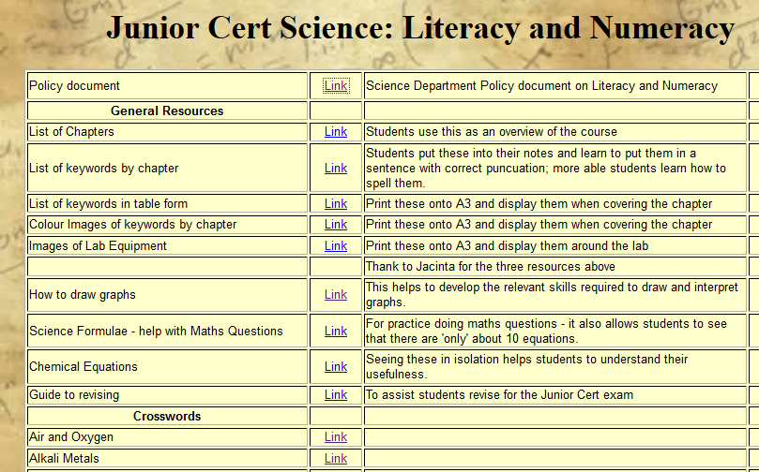

The following is an extract from the SCC Literacy and Numeracy document; over the next few years we hope to include many of these ideas in our own policy.

Current Initiatives in the Areas of Literacy and Numeracy (extract from the SCC policy document)
Science
- Wordgames. Ex: Hangman
- Crosswords
- Card games
- Poster making- formulae
- Bought posters with formulae etc
- Explanation of terms on board
- Visual displays- teaching equations- use a balance
- Students design number lines
- Fill in the blanks
- A/B/C/D quiz (read the question on board and students hold up a letter with the right answer
- Writing answers on the board
- Matching games
- Understanding graphs
- Keywords in topic
- Spider diagrams
- Answer a question but saying “why?”
- Creating powerpoints
- Explaining in a student’s own words
- Correct spelling / grammar in class
- Reading articles
- Project work- create and present to the class
- “Term Bingo”- match new words / terms to definitions
- Match terms to diagrams on laminated cards etc
- Teaching through song
- Use of mnemonics
- Summary sheets after topics
- Use of internet programmes- maths/science sites…
- Revision and practice of oral work; this increases competence and confidence without handwritten notes
- Reading out notes while the student takes them down
- Spelling words for students / helping students to spell words for themselves
- Helping organisation- does the student have books, copies etc
- Written version of notes for students with laptops
- Listen to problems- helping to formulate and express problems
- Using computers- spell check, sounding out words that do not match spell check and persevering until they get a match

Physics
- Fold over an A4 sheet- term on one side, explanation on the other
- Quizlet.com- electronic flash cards- student can log in and compete in games
- Magazines- New Scientist – make posters using these / read in class / students take one for homework and present in class
- Highlight key words and numbers in questions
- Students keep a “Word Bank”- notebook of key terms
- Avoiding highly idiomatic terms when working with non-nationals
- Use of Google Maps to get distances to places from school- Ex Bray, city centre, New York.
- Mind map on Whiteboard- students photo this
- Using essays by physicists. Ex- “On Being the Right Size”
- Fermi questions. Ex- “How much would you charge to wash all the cars in Dublin?”
- Students make videos on experiments- they write and perform the script
- Crosswords

